Homeless Coalition of Greater Battle Creek & Calhoun County

Tuesday, January 17, 2023 12pm – 1pm
Location: Zoom Call

- Welcome and Introductions – Nicole DuPont
  - Please subscribe to the Homeless Coalition Listserv for the most updated information from this coalition: http://eepurl.com/cwoyDP
  - New team members?

- Announcement
  - Intersectionality between Trauma-Informed Care and Domestic Violence Training

- Training & Presentations
  - LGBTQ+ Homeless Population -Jaimie Fales, First Congregational Church Battle Creek
    - Have showers available; accessible for those disabled
    - Are open and affirming to LGBTQ+
    - Barriers to access for those unhoused; safest and best housing shelter option; esp if non-binary or transgender; feel bias; advocate for reflective questions – are policies and procedures offer support/trainings/staff understanding
    - For legal purposes must use dead name or given name; they have to perform code switching for legal purposes
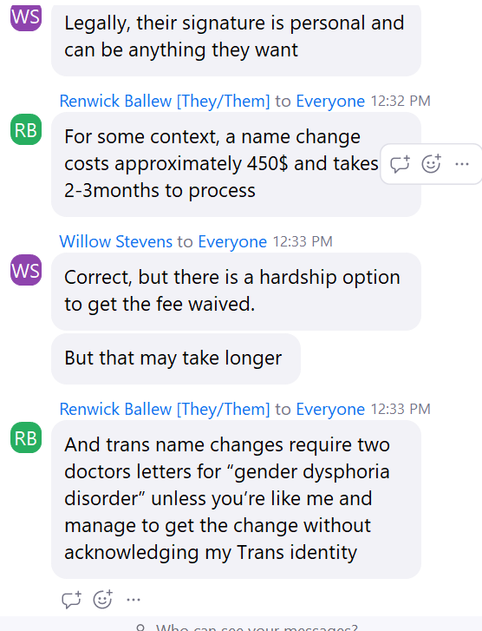
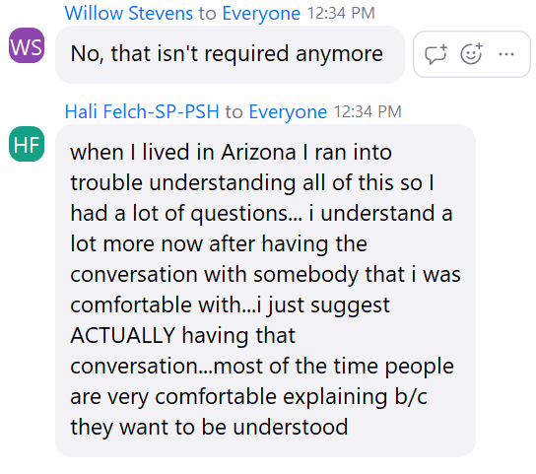
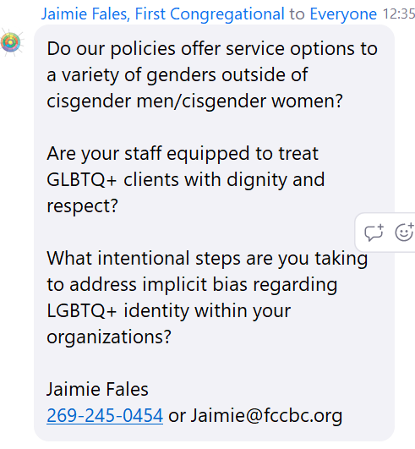

- Grants
  - BC Rotary Grant – Emergency Sleeping Mats

- Housing Solutions Board Update
  - Vote on MSHDA-CV funds $75k today

- PIT Count 2023 – NIBC - Brendan

- New Business

  - Direct Services Update – Melissa Smith, Daniel Jones, Olivia Harvey, Robert Elchert
    - Haven – Ice Jam at Woodland Church
    - Battle Creek Shelter - business as usual - full
    - SAFE Place – business as usual – full; can serve age 13 and up who are survivors of sex trafficking (can stay up to 5 days)
    - SHARE Center – business as usual
  - HARA (Neighborhoods Inc.) Update – Whitney Wardell - $4k in ESG prevention; CV allocation
    - Rental Roundtable upcoming in next few months
  - HC Agencies’ Updates

- Updates on collaborative workgroups:
- HMIS Data Quality User Group – Nancy Doyal
  - LSA submitted; PIT Count data next; SPM then submitted
- Veteran by Name List – Cindy Carrier, Michelle Pascoe
  - TBD
- Interagency Services Team – Cindy Carrier, Chair
  - Mt Thursday at 2pm

- Rental Housing Roundtable – Whitney Wardell

- Income Increase / Employment – Robert Elchert, Stacia Williams
  - TBD – Stacia is employment and benefits coach
- Hunger Free Calhoun – Homeless – Marsha Keefer

- Street Outreach – PATH and Haven –Ron Leigh, Justin Heflin, Todd Artis, Mitch Misiasz

- Coordinated Entry System – Nicole DuPont

Homeless Connect – 252 attendees; Next one is October 20th; appeal to join planning group.

- Next Meeting
  - March 21, 2023 @ 12:00PM via Zoom
